Федеральное агентство связи

Федеральное государственное бюджетное образовательное учреждение высшего образования

«Сибирский государственный университет телекоммуникаций и информатики»

Кафедра прикладной математики и кибернетики

Отчет по лабораторной работе

по дисциплине «Визуальное программирование»

Лабораторная работа № 4

«Создание файлового менеджера»

Выполнил: студент 2 курса группы ИП-811 Мироненко К. А

Проверил: доцент кафедры ПМиК Ситняковская Е. И.

**Оглавление**

1. Постановка задачи 3

2. Описание работы 5

3. Примеры работы программы 6

*Приложение* Листинг 9

# Постановка задачи

*Задание 1.* Создать форму как показано на рисунке 1.

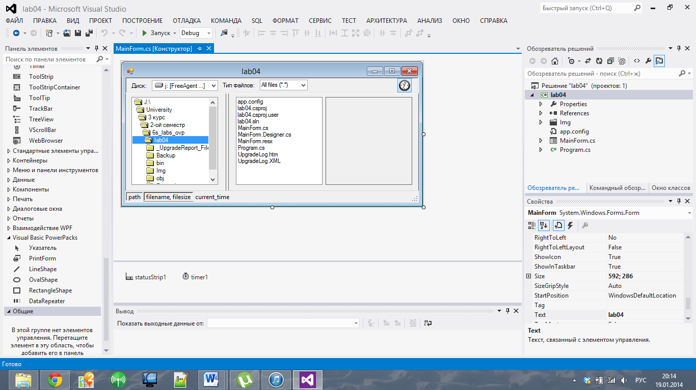

Рис.1

*Задание 2.* Изменить Form1 на рис. 1 (задание 1) следующим образом: использовать для реализации строки состояния вместо компонента Panel компонент StatusBar. Структура компонента StatusBar показана на рис. 2.

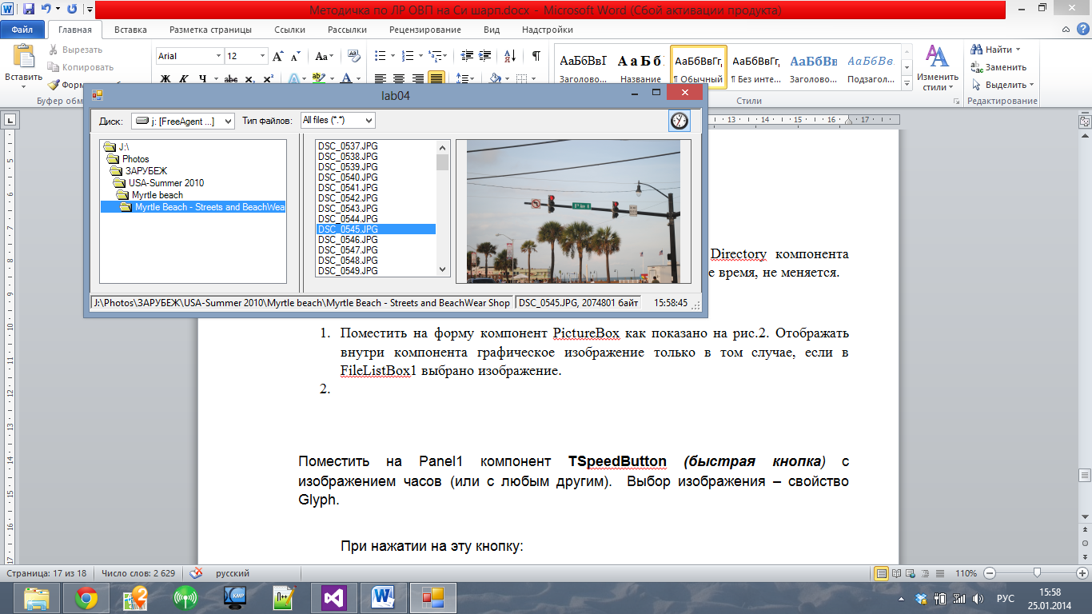

Рис. 2

*Задание 3:*

1. Поместить на форму компонент PictureBox как показано на рис.2. Отображать внутри компонента графическое изображение только в том случае, если в FileListBox1 выбрано изображение.
2. Поместить на Panel1 компонент RadioButton ***(***быстрая кнопка*)* с изображением часов (или с любым другим).

При нажатии на эту кнопку:

* время в строке статуса должно выключаться;
* состояние кнопки - нажата.

# Описание работы

Работа приложения соответствует описанию в методичке, за исключением именования и свойств некоторых элементов.

# Примеры работы программы

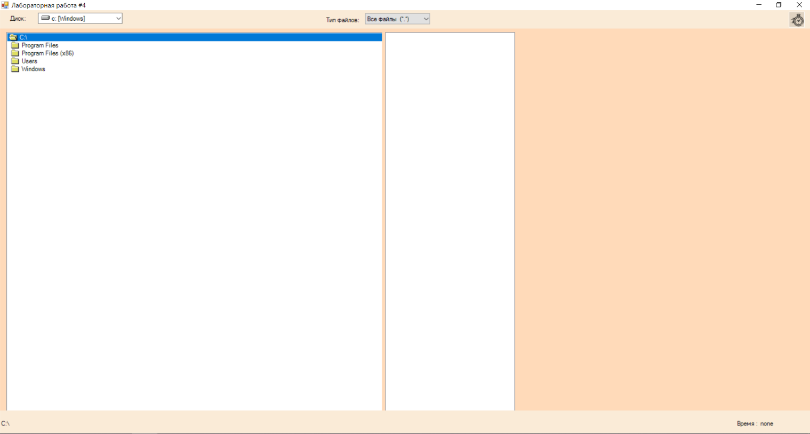

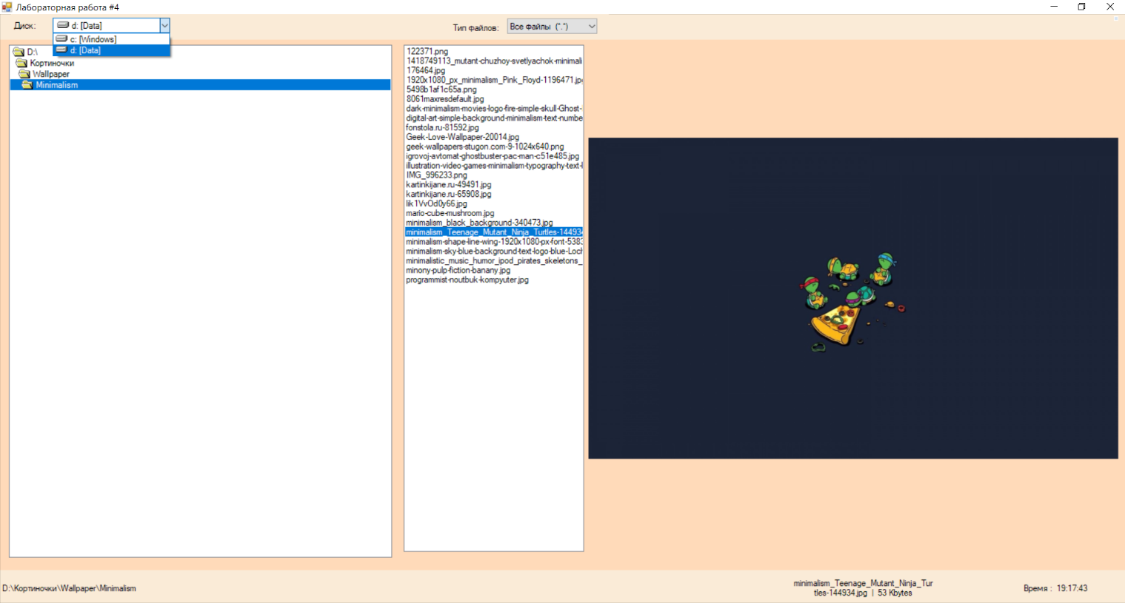

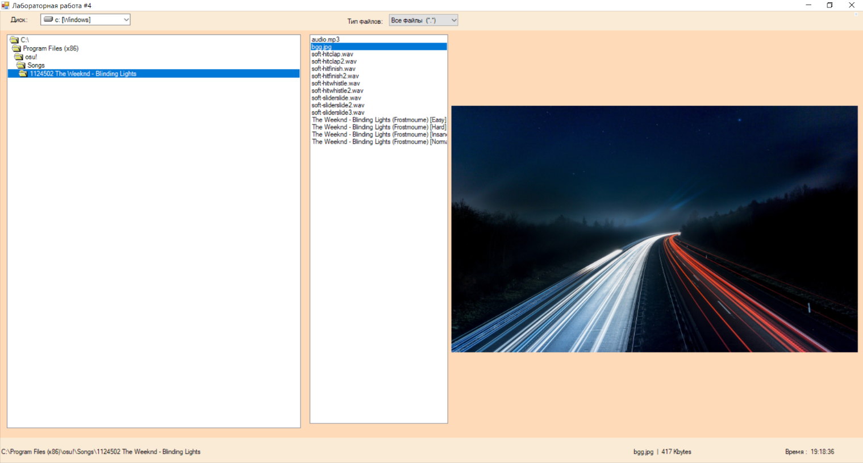

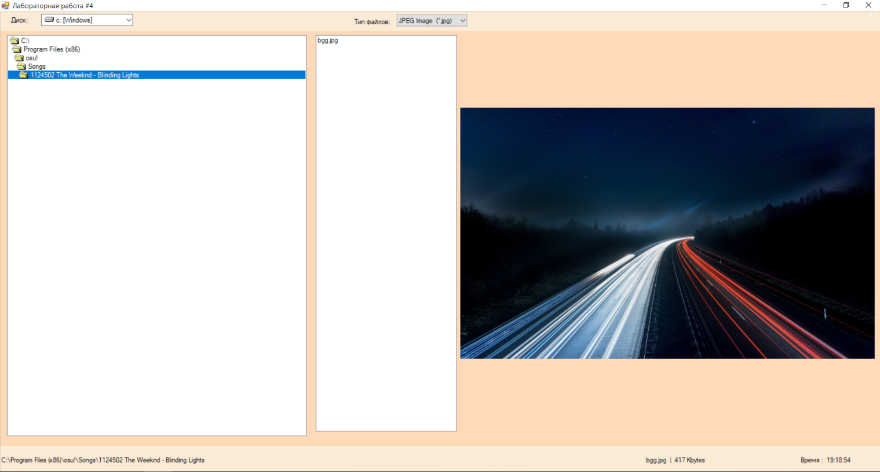

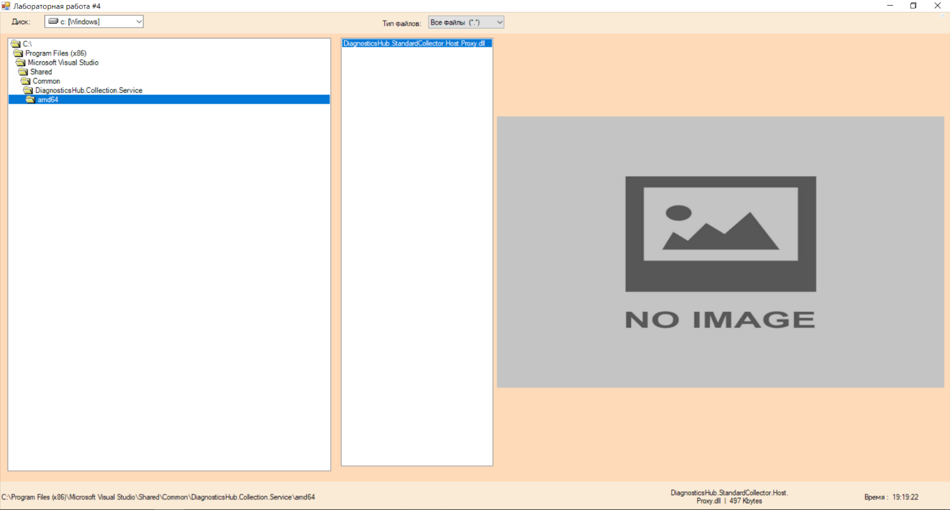

# *Приложение* Листинг

**Program.cs**

using System;

using System.Collections.Generic;

using System.Linq;

using System.Threading.Tasks;

using System.Windows.Forms;

namespace laboratoryWork_4

{

static class Program

{

/// <summary>

/// The main entry point for the application.

/// </summary>

[STAThread]

static void Main()

{

Application.EnableVisualStyles();

Application.SetCompatibleTextRenderingDefault(false);

Application.Run(new FormMain());

}

}

}

**FormMain.cs**

using System;

using System.Collections.Generic;

using System.ComponentModel;

using System.Data;

using System.Drawing;

using System.IO;

using System.Linq;

using System.Text;

using System.Threading.Tasks;

using System.Windows.Forms;

namespace laboratoryWork_4

{

public partial class FormMain : Form

{

public FormMain()

{

InitializeComponent();

}

private void FormMain_Load(object sender, EventArgs e)

{

type_comboBox.SelectedIndex = 0;

type_comboBox_SelectionChangeCommitted(null, null);

driveListBox.SelectedIndex = 0;

driveListBox_SelectionChangeCommitted(null, null);

}

private void driveListBox_SelectionChangeCommitted(object sender, EventArgs e)

{

try

{

dirListBox.Path = driveListBox.Drive.Substring(0,1).ToUpper() +":\\";

dirListBox.SelectedIndex = 0;

dirListBox_MouseDoubleClick(null, null);

}

catch (System.Exception ex)

{

System.Windows.Forms.MessageBox.Show(ex.Message);

}

}

private void dirListBox_MouseDoubleClick(object sender, MouseEventArgs e)

{

fileListBox.Path = dirListBox.Path;

try

{

fileListBox.SelectedIndex = 0;

}

catch { }

path_label.Text = dirListBox.Path;

}

private void type_comboBox_SelectionChangeCommitted(object sender, EventArgs e)

{

try

{

if (type_comboBox.Text == type_comboBox.Items[0].ToString())

{

fileListBox.Pattern = "*.*";

}

else if (type_comboBox.Text == type_comboBox.Items[1].ToString())

{

fileListBox.Pattern = "*.jpg";

}

else if (type_comboBox.Text == type_comboBox.Items[2].ToString())

{

fileListBox.Pattern = "*.bmp";

}

else if (type_comboBox.Text == type_comboBox.Items[3].ToString())

{

fileListBox.Pattern = "*.gif";

}

else if (type_comboBox.Text == type_comboBox.Items[4].ToString())

{

fileListBox.Pattern = "*.png";

}

}

catch (System.Exception ex)

{

System.Windows.Forms.MessageBox.Show(ex.Message);

}

}

private void fileListBox_SelectedValueChanged(object sender, EventArgs e)

{

if (fileListBox.SelectedItem.ToString() != "")

{

double size;

FileInfo file = new FileInfo((fileListBox.Path + "\\" + fileListBox.SelectedItem));

size = file.Length / 1024;

file_label.Text = fileListBox.SelectedItem + " | " + size + " Kbytes";

pictureBox.SizeMode = PictureBoxSizeMode.StretchImage;

Image img;

try

{

img = Image.FromFile(file.ToString());

}

catch

{

img = Properties.Resources.no;

}

pictureBox.Image = img;

}

else

{

pictureBox.Image = null;

}

}

private void timer_Tick(object sender, EventArgs e)

{

DateTime time = DateTime.Now;

time_label.Text = "Время : " + time.ToLongTimeString();

}

private void checkBox1_CheckedChanged(object sender, EventArgs e)

{

timer.Enabled = !timer.Enabled;

if (!timer.Enabled)

{

time_label.Text = "Время : none";

}

}

}

}

**FormMain.Designer.cs**

namespace laboratoryWork_4

{

partial class FormMain

{

/// <summary>

/// Required designer variable.

/// </summary>

private System.ComponentModel.IContainer components = null;

/// <summary>

/// Clean up any resources being used.

/// </summary>

/// <param name="disposing">true if managed resources should be disposed; otherwise, false.</param>

protected override void Dispose(bool disposing)

{

if (disposing && (components != null))

{

components.Dispose();

}

base.Dispose(disposing);

}

#region Windows Form Designer generated code

/// <summary>

/// Required method for Designer support - do not modify

/// the contents of this method with the code editor.

/// </summary>

private void InitializeComponent()

{

this.components = new System.ComponentModel.Container();

this.panel_top = new System.Windows.Forms.Panel();

this.checkBox1 = new System.Windows.Forms.CheckBox();

this.label1 = new System.Windows.Forms.Label();

this.driveListBox = new Microsoft.VisualBasic.Compatibility.VB6.DriveListBox();

this.type_comboBox = new System.Windows.Forms.ComboBox();

this.label2 = new System.Windows.Forms.Label();

this.panel_main = new System.Windows.Forms.Panel();

this.splitContainer1 = new System.Windows.Forms.SplitContainer();

this.dirListBox = new Microsoft.VisualBasic.Compatibility.VB6.DirListBox();

this.pictureBox = new System.Windows.Forms.PictureBox();

this.fileListBox = new Microsoft.VisualBasic.Compatibility.VB6.FileListBox();

this.panel1 = new System.Windows.Forms.Panel();

this.panel3 = new System.Windows.Forms.Panel();

this.time_label = new System.Windows.Forms.Label();

this.panel2 = new System.Windows.Forms.Panel();

this.file_label = new System.Windows.Forms.Label();

this.path_panel = new System.Windows.Forms.Panel();

this.path_label = new System.Windows.Forms.Label();

this.timer = new System.Windows.Forms.Timer(this.components);

this.panel_top.SuspendLayout();

this.panel_main.SuspendLayout();

((System.ComponentModel.ISupportInitialize) (this.splitContainer1)).BeginInit();

this.splitContainer1.Panel1.SuspendLayout();

this.splitContainer1.Panel2.SuspendLayout();

this.splitContainer1.SuspendLayout();

((System.ComponentModel.ISupportInitialize) (this.pictureBox)).BeginInit();

this.panel1.SuspendLayout();

this.panel3.SuspendLayout();

this.panel2.SuspendLayout();

this.path_panel.SuspendLayout();

this.SuspendLayout();

//

// panel_top

//

this.panel_top.Anchor = ((System.Windows.Forms.AnchorStyles) (((System.Windows.Forms.AnchorStyles.Top | System.Windows.Forms.AnchorStyles.Left) | System.Windows.Forms.AnchorStyles.Right)));

this.panel_top.Controls.Add(this.checkBox1);

this.panel_top.Controls.Add(this.label1);

this.panel_top.Controls.Add(this.driveListBox);

this.panel_top.Controls.Add(this.type_comboBox);

this.panel_top.Controls.Add(this.label2);

this.panel_top.Location = new System.Drawing.Point(0, 0);

this.panel_top.Margin = new System.Windows.Forms.Padding(4);

this.panel_top.Name = "panel_top";

this.panel_top.Size = new System.Drawing.Size(1069, 44);

this.panel_top.TabIndex = 3;

//

// checkBox1

//

this.checkBox1.Anchor = ((System.Windows.Forms.AnchorStyles) ((System.Windows.Forms.AnchorStyles.Top | System.Windows.Forms.AnchorStyles.Right)));

this.checkBox1.Appearance = System.Windows.Forms.Appearance.Button;

this.checkBox1.AutoSize = true;

this.checkBox1.CheckAlign = System.Drawing.ContentAlignment.MiddleCenter;

this.checkBox1.Checked = true;

this.checkBox1.CheckState = System.Windows.Forms.CheckState.Checked;

this.checkBox1.Cursor = System.Windows.Forms.Cursors.Hand;

this.checkBox1.FlatAppearance.BorderColor = System.Drawing.Color.White;

this.checkBox1.FlatAppearance.CheckedBackColor = System.Drawing.SystemColors.GradientInactiveCaption;

this.checkBox1.FlatStyle = System.Windows.Forms.FlatStyle.Flat;

this.checkBox1.Location = new System.Drawing.Point(1047, 4);

this.checkBox1.Margin = new System.Windows.Forms.Padding(4);

this.checkBox1.Name = "checkBox1";

this.checkBox1.Size = new System.Drawing.Size(6, 6);

this.checkBox1.TabIndex = 6;

this.checkBox1.TextAlign = System.Drawing.ContentAlignment.MiddleCenter;

this.checkBox1.UseVisualStyleBackColor = true;

this.checkBox1.CheckedChanged += new System.EventHandler(this.checkBox1_CheckedChanged);

//

// label1

//

this.label1.ImageAlign = System.Drawing.ContentAlignment.MiddleLeft;

this.label1.Location = new System.Drawing.Point(11, 0);

this.label1.Margin = new System.Windows.Forms.Padding(4, 0, 4, 0);

this.label1.Name = "label1";

this.label1.Size = new System.Drawing.Size(71, 37);

this.label1.TabIndex = 3;

this.label1.Text = "Диск:";

this.label1.TextAlign = System.Drawing.ContentAlignment.MiddleCenter;

//

// driveListBox

//

this.driveListBox.Anchor = ((System.Windows.Forms.AnchorStyles) (((System.Windows.Forms.AnchorStyles.Top | System.Windows.Forms.AnchorStyles.Bottom) | System.Windows.Forms.AnchorStyles.Left)));

this.driveListBox.FormattingEnabled = true;

this.driveListBox.Location = new System.Drawing.Point(96, 6);

this.driveListBox.Margin = new System.Windows.Forms.Padding(4);

this.driveListBox.Name = "driveListBox";

this.driveListBox.Size = new System.Drawing.Size(212, 23);

this.driveListBox.TabIndex = 0;

this.driveListBox.SelectionChangeCommitted += new System.EventHandler(this.driveListBox_SelectionChangeCommitted);

//

// type_comboBox

//

this.type_comboBox.Anchor = ((System.Windows.Forms.AnchorStyles) ((System.Windows.Forms.AnchorStyles.Top | System.Windows.Forms.AnchorStyles.Bottom)));

this.type_comboBox.DropDownStyle = System.Windows.Forms.ComboBoxStyle.DropDownList;

this.type_comboBox.FormattingEnabled = true;

this.type_comboBox.Items.AddRange(new object[] {"Все файлы (*.*)", "JPEG Image (*.jpg)", "itmap Image (*.bmp)", "GIF image (*.gif)", "PNG Image (*.png)", "Все файлы (*.*)", "JPEG Image (*.jpg)", "itmap Image (*.bmp)", "GIF image (*.gif)", "PNG Image (*.png)"});

this.type_comboBox.Location = new System.Drawing.Point(432, 7);

this.type_comboBox.Margin = new System.Windows.Forms.Padding(4);

this.type_comboBox.Name = "type_comboBox";

this.type_comboBox.Size = new System.Drawing.Size(163, 24);

this.type_comboBox.TabIndex = 1;

this.type_comboBox.SelectionChangeCommitted += new System.EventHandler(this.type_comboBox_SelectionChangeCommitted);

//

// label2

//

this.label2.Anchor = ((System.Windows.Forms.AnchorStyles) ((System.Windows.Forms.AnchorStyles.Top | System.Windows.Forms.AnchorStyles.Bottom)));

this.label2.Location = new System.Drawing.Point(328, 0);

this.label2.Margin = new System.Windows.Forms.Padding(4, 0, 4, 0);

this.label2.Name = "label2";

this.label2.Size = new System.Drawing.Size(96, 44);

this.label2.TabIndex = 2;

this.label2.Text = "Тип файлов:";

this.label2.TextAlign = System.Drawing.ContentAlignment.MiddleCenter;

//

// panel_main

//

this.panel_main.Anchor = ((System.Windows.Forms.AnchorStyles) ((((System.Windows.Forms.AnchorStyles.Top | System.Windows.Forms.AnchorStyles.Bottom) | System.Windows.Forms.AnchorStyles.Left) | System.Windows.Forms.AnchorStyles.Right)));

this.panel_main.BackColor = System.Drawing.Color.PeachPuff;

this.panel_main.Controls.Add(this.splitContainer1);

this.panel_main.Location = new System.Drawing.Point(0, 43);

this.panel_main.Margin = new System.Windows.Forms.Padding(4);

this.panel_main.Name = "panel_main";

this.panel_main.Size = new System.Drawing.Size(1069, 529);

this.panel_main.TabIndex = 1;

//

// splitContainer1

//

this.splitContainer1.Dock = System.Windows.Forms.DockStyle.Fill;

this.splitContainer1.Location = new System.Drawing.Point(0, 0);

this.splitContainer1.Margin = new System.Windows.Forms.Padding(4);

this.splitContainer1.Name = "splitContainer1";

//

// splitContainer1.Panel1

//

this.splitContainer1.Panel1.Controls.Add(this.dirListBox);

//

// splitContainer1.Panel2

//

this.splitContainer1.Panel2.Controls.Add(this.pictureBox);

this.splitContainer1.Panel2.Controls.Add(this.fileListBox);

this.splitContainer1.Size = new System.Drawing.Size(1069, 529);

this.splitContainer1.SplitterDistance = 378;

this.splitContainer1.SplitterWidth = 5;

this.splitContainer1.TabIndex = 4;

//

// dirListBox

//

this.dirListBox.Anchor = ((System.Windows.Forms.AnchorStyles) ((((System.Windows.Forms.AnchorStyles.Top | System.Windows.Forms.AnchorStyles.Bottom) | System.Windows.Forms.AnchorStyles.Left) | System.Windows.Forms.AnchorStyles.Right)));

this.dirListBox.Cursor = System.Windows.Forms.Cursors.Default;

this.dirListBox.FormattingEnabled = true;

this.dirListBox.IntegralHeight = false;

this.dirListBox.Location = new System.Drawing.Point(16, 9);

this.dirListBox.Margin = new System.Windows.Forms.Padding(4);

this.dirListBox.Name = "dirListBox";

this.dirListBox.Size = new System.Drawing.Size(348, 499);

this.dirListBox.TabIndex = 3;

this.dirListBox.MouseDoubleClick += new System.Windows.Forms.MouseEventHandler(this.dirListBox_MouseDoubleClick);

//

// pictureBox

//

this.pictureBox.Anchor = ((System.Windows.Forms.AnchorStyles) ((((System.Windows.Forms.AnchorStyles.Top | System.Windows.Forms.AnchorStyles.Bottom) | System.Windows.Forms.AnchorStyles.Left) | System.Windows.Forms.AnchorStyles.Right)));

this.pictureBox.ErrorImage = null;

this.pictureBox.Location = new System.Drawing.Point(340, 165);

this.pictureBox.Margin = new System.Windows.Forms.Padding(4);

this.pictureBox.Name = "pictureBox";

this.pictureBox.Size = new System.Drawing.Size(328, 177);

this.pictureBox.SizeMode = System.Windows.Forms.PictureBoxSizeMode.StretchImage;

this.pictureBox.TabIndex = 1;

this.pictureBox.TabStop = false;

//

// fileListBox

//

this.fileListBox.Anchor = ((System.Windows.Forms.AnchorStyles) (((System.Windows.Forms.AnchorStyles.Top | System.Windows.Forms.AnchorStyles.Bottom) | System.Windows.Forms.AnchorStyles.Left)));

this.fileListBox.FormattingEnabled = true;

this.fileListBox.Location = new System.Drawing.Point(4, 9);

this.fileListBox.Margin = new System.Windows.Forms.Padding(4);

this.fileListBox.Name = "fileListBox";

this.fileListBox.Pattern = "*.*";

this.fileListBox.Size = new System.Drawing.Size(327, 500);

this.fileListBox.TabIndex = 5;

this.fileListBox.SelectedValueChanged += new System.EventHandler(this.fileListBox_SelectedValueChanged);

//

// panel1

//

this.panel1.Anchor = ((System.Windows.Forms.AnchorStyles) (((System.Windows.Forms.AnchorStyles.Bottom | System.Windows.Forms.AnchorStyles.Left) | System.Windows.Forms.AnchorStyles.Right)));

this.panel1.Controls.Add(this.panel3);

this.panel1.Controls.Add(this.panel2);

this.panel1.Controls.Add(this.path_panel);

this.panel1.Location = new System.Drawing.Point(0, 580);

this.panel1.Margin = new System.Windows.Forms.Padding(4);

this.panel1.Name = "panel1";

this.panel1.Size = new System.Drawing.Size(1069, 46);

this.panel1.TabIndex = 2;

//

// panel3

//

this.panel3.Anchor = ((System.Windows.Forms.AnchorStyles) (((System.Windows.Forms.AnchorStyles.Top | System.Windows.Forms.AnchorStyles.Bottom) | System.Windows.Forms.AnchorStyles.Right)));

this.panel3.AutoScroll = true;

this.panel3.Controls.Add(this.time_label);

this.panel3.Location = new System.Drawing.Point(803, 0);

this.panel3.Margin = new System.Windows.Forms.Padding(4);

this.panel3.Name = "panel3";

this.panel3.Size = new System.Drawing.Size(263, 46);

this.panel3.TabIndex = 2;

//

// time_label

//

this.time_label.Anchor = ((System.Windows.Forms.AnchorStyles) (((System.Windows.Forms.AnchorStyles.Top | System.Windows.Forms.AnchorStyles.Bottom) | System.Windows.Forms.AnchorStyles.Right)));

this.time_label.AutoEllipsis = true;

this.time_label.Location = new System.Drawing.Point(75, 0);

this.time_label.Margin = new System.Windows.Forms.Padding(13, 0, 7, 0);

this.time_label.Name = "time_label";

this.time_label.Size = new System.Drawing.Size(176, 46);

this.time_label.TabIndex = 0;

this.time_label.Text = "Время:";

this.time_label.TextAlign = System.Drawing.ContentAlignment.MiddleLeft;

//

// panel2

//

this.panel2.Anchor = ((System.Windows.Forms.AnchorStyles) (((System.Windows.Forms.AnchorStyles.Top | System.Windows.Forms.AnchorStyles.Bottom) | System.Windows.Forms.AnchorStyles.Right)));

this.panel2.AutoScroll = true;

this.panel2.Controls.Add(this.file_label);

this.panel2.Location = new System.Drawing.Point(460, 0);

this.panel2.Margin = new System.Windows.Forms.Padding(4);

this.panel2.Name = "panel2";

this.panel2.Size = new System.Drawing.Size(263, 46);

this.panel2.TabIndex = 1;

//

// file_label

//

this.file_label.AutoEllipsis = true;

this.file_label.Dock = System.Windows.Forms.DockStyle.Fill;

this.file_label.Location = new System.Drawing.Point(0, 0);

this.file_label.Margin = new System.Windows.Forms.Padding(13, 0, 7, 0);

this.file_label.Name = "file_label";

this.file_label.Size = new System.Drawing.Size(263, 46);

this.file_label.TabIndex = 0;

this.file_label.TextAlign = System.Drawing.ContentAlignment.MiddleCenter;

//

// path_panel

//

this.path_panel.Anchor = ((System.Windows.Forms.AnchorStyles) ((((System.Windows.Forms.AnchorStyles.Top | System.Windows.Forms.AnchorStyles.Bottom) | System.Windows.Forms.AnchorStyles.Left) | System.Windows.Forms.AnchorStyles.Right)));

this.path_panel.AutoScroll = true;

this.path_panel.Controls.Add(this.path_label);

this.path_panel.Location = new System.Drawing.Point(0, 0);

this.path_panel.Margin = new System.Windows.Forms.Padding(4);

this.path_panel.Name = "path_panel";

this.path_panel.Size = new System.Drawing.Size(424, 46);

this.path_panel.TabIndex = 0;

//

// path_label

//

this.path_label.AutoEllipsis = true;

this.path_label.Dock = System.Windows.Forms.DockStyle.Fill;

this.path_label.Location = new System.Drawing.Point(0, 0);

this.path_label.Margin = new System.Windows.Forms.Padding(13, 0, 7, 0);

this.path_label.Name = "path_label";

this.path_label.Size = new System.Drawing.Size(424, 46);

this.path_label.TabIndex = 0;

this.path_label.Text = "Путь";

this.path_label.TextAlign = System.Drawing.ContentAlignment.MiddleLeft;

//

// timer

//

this.timer.Enabled = true;

this.timer.Interval = 1000;

this.timer.Tick += new System.EventHandler(this.timer_Tick);

//

// FormMain

//

this.AutoScaleDimensions = new System.Drawing.SizeF(8F, 16F);

this.AutoScaleMode = System.Windows.Forms.AutoScaleMode.Font;

this.BackColor = System.Drawing.Color.AntiqueWhite;

this.ClientSize = new System.Drawing.Size(1067, 623);

this.Controls.Add(this.panel1);

this.Controls.Add(this.panel_main);

this.Controls.Add(this.panel_top);

this.Location = new System.Drawing.Point(15, 15);

this.Margin = new System.Windows.Forms.Padding(4);

this.MinimumSize = new System.Drawing.Size(1082, 661);

this.Name = "FormMain";

this.StartPosition = System.Windows.Forms.FormStartPosition.CenterScreen;

this.Text = "Лабораторная работа #4";

this.WindowState = System.Windows.Forms.FormWindowState.Maximized;

this.Load += new System.EventHandler(this.FormMain_Load);

this.panel_top.ResumeLayout(false);

this.panel_top.PerformLayout();

this.panel_main.ResumeLayout(false);

this.splitContainer1.Panel1.ResumeLayout(false);

this.splitContainer1.Panel2.ResumeLayout(false);

((System.ComponentModel.ISupportInitialize) (this.splitContainer1)).EndInit();

this.splitContainer1.ResumeLayout(false);

((System.ComponentModel.ISupportInitialize) (this.pictureBox)).EndInit();

this.panel1.ResumeLayout(false);

this.panel3.ResumeLayout(false);

this.panel2.ResumeLayout(false);

this.path_panel.ResumeLayout(false);

this.ResumeLayout(false);

}

private System.Windows.Forms.CheckBox checkBox1;

private Microsoft.VisualBasic.Compatibility.VB6.DirListBox dirListBox;

private Microsoft.VisualBasic.Compatibility.VB6.DriveListBox driveListBox;

private System.Windows.Forms.Label file_label;

private Microsoft.VisualBasic.Compatibility.VB6.FileListBox fileListBox;

private System.Windows.Forms.Label label1;

private System.Windows.Forms.Label label2;

private System.Windows.Forms.Panel panel_main;

private System.Windows.Forms.Panel panel_top;

private System.Windows.Forms.Panel panel1;

private System.Windows.Forms.Panel panel2;

private System.Windows.Forms.Panel panel3;

private System.Windows.Forms.Label path_label;

private System.Windows.Forms.Panel path_panel;

private System.Windows.Forms.PictureBox pictureBox;

private System.Windows.Forms.SplitContainer splitContainer1;

private System.Windows.Forms.Label time_label;

private System.Windows.Forms.Timer timer;

private System.Windows.Forms.ComboBox type_comboBox;

#endregion

}

}